**PUBLISH DATA TO THE IBM CLOUD**

|  |  |
| --- | --- |
| TEAM ID | PNT2022TMID00923 |
| PROJECT NAME | Signs with Smart Connectivity for Better Road Safety |

**STEPS TO PUBLISH DATA TO IBM CLOUD:**

**STEP-1:** Sign in to the created IBM IoT platform.

**STEP-2:** Select organisation from drop down in the right top corner.

**STEP-3:** Click on to add device and enter the device type and device id.

**STEP-4:** Click next until you get the device credentials which are the device type, device id, authentication method and authentication token.

**STEP-5:** Enter all those credentials in the python code and import ibmiotf.application and ibmiotf.device libraries.

**STEP-6:** Create data in json format and enter syntax that pushes the data to IBM IoT platform

**STEP-7:** The data is displayed in the corresponding device under the RECENT EVENTS tab.

**CODE SPECIFIACTIONS:**

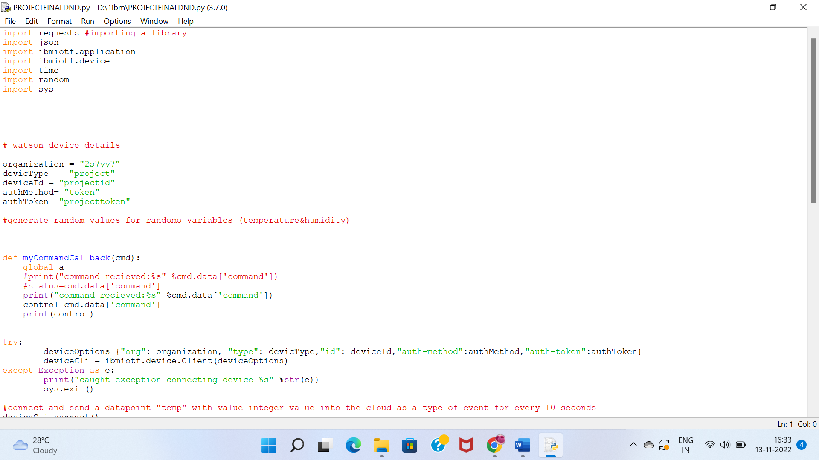

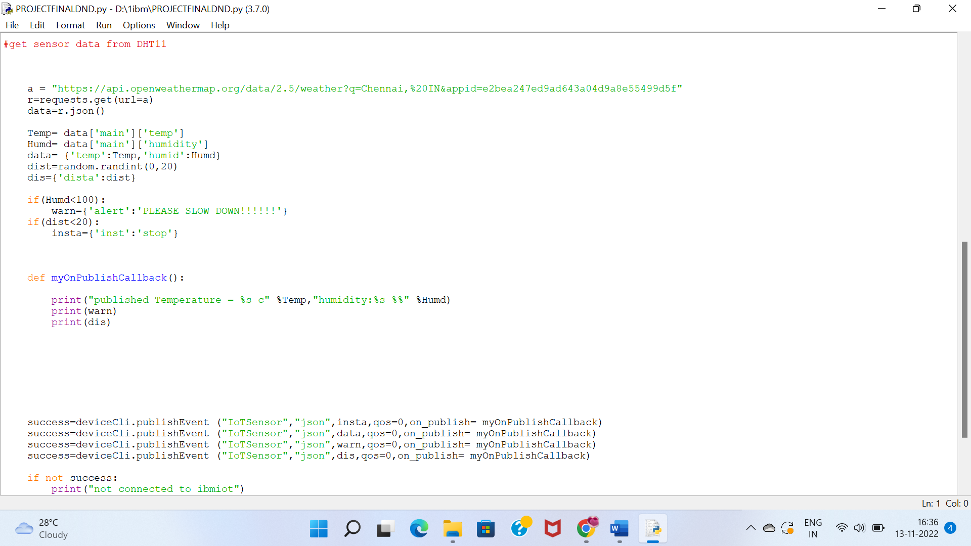

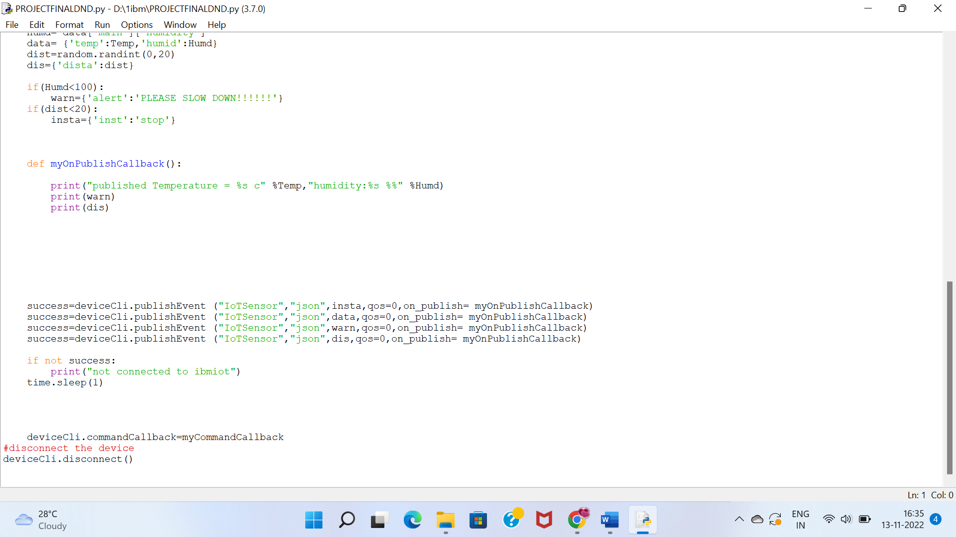

**IBM IoT WATSON PLATFORM:**

